**Project documentation**

* Run backend project on server “localhost:9119”.
* Run angular project on server “localhost:4200”.
* Log in to project with “admin@gmail.com” and “admin”. 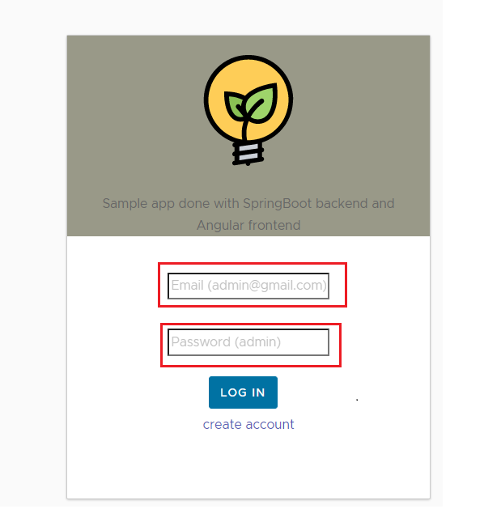
* Click to “technology stack” option in the home page.

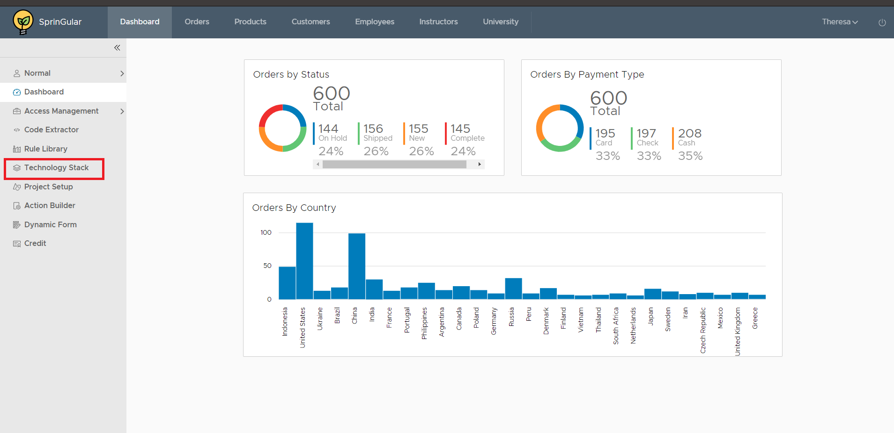

* Go-to the technology stack and click “ADD” button to crate form .

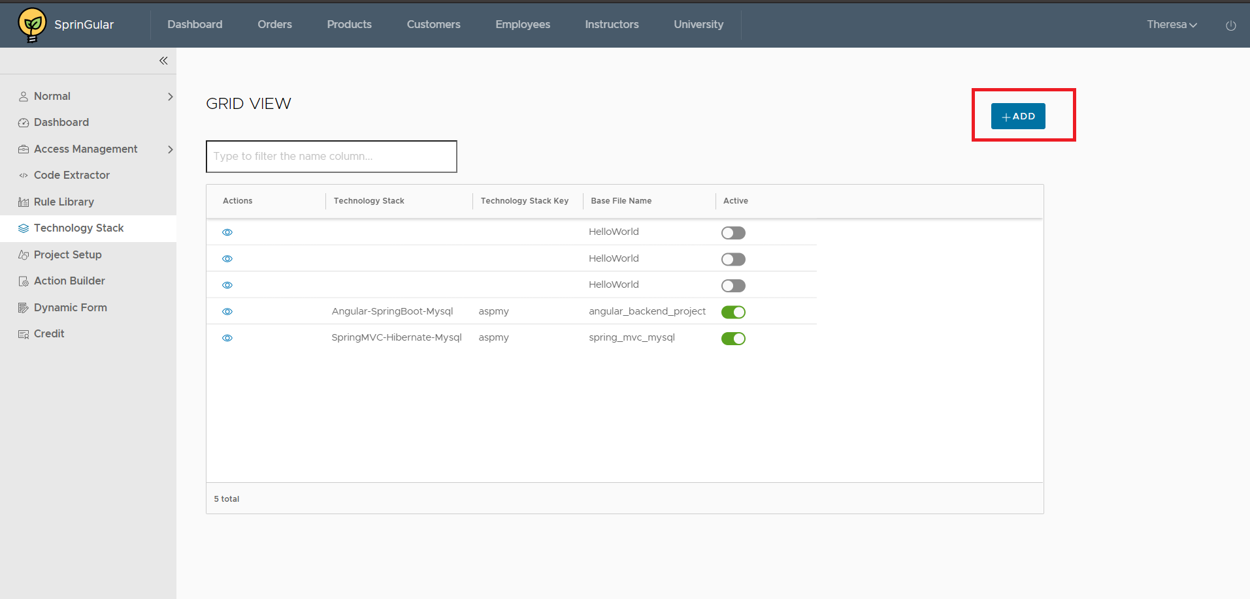

**Technical details: on technology stack click**

1. **Controller:** Technologystackcontroller
2. **Service:** Rn_Bcf_technologyStack_service
3. **Entity:** Rn_Bcf_technologyStack
4. **Repository:** Rn_Bcf_technologyStack_Repository
5. **Table:** Rn_Bcf_Technology_Stack

* Fill the form information in the technology stack form choose technology, tags and upload zip file and

Submit the form.

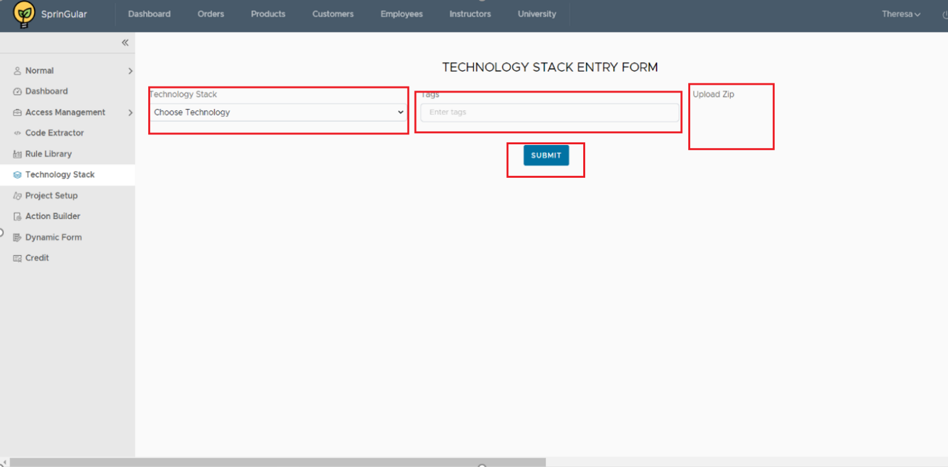

**Technical details: on click add button in the technology stack**

1. **Controller:** Technologystackcontroller
2. **Service:** Rn_Bcf_TechnologyStack_Service(for data save) ,fileStorageService(for file)
3. **Entity:** Rn_Bcf_TechnologyStack
4. **Repository:** Rn_Bcf_TechnologyStack_Repository
5. **Table:** Rn_Bcf_Technology_Stack

**Populated field:**

Choose technology: dropdown static

Upload zip: only upload zip file only

**Service** : ApiRequestService(post method)

**On button submit**: when we click on submit button then technologystackservice called ad data stored in the table

RN_BCF_TECHNOLOGY_STACK. Also zip file be unzip in backend and this project is added in base project. You can see project is added in base project.(unzip file).

* After that , go-to project setup option and click add button to create project

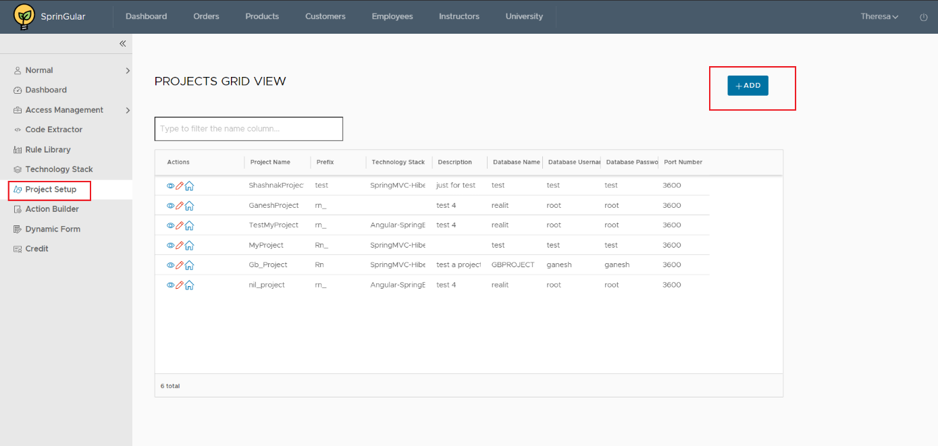

**Technical details: on click project setup**

1. **Controller:** Rn_projectSetupController
2. **Service:** Rn_ProjectSetup_Service
3. **Entity:** Rn_Project_Setup
4. **Repository:** Rn_ProjectSetup_repository
5. **Table:** Rn_Project_Setup

* If you want to copy existing project then fill the copy project information like choose project ,project name, choose technology stack and click copy to generate project.
* If you want to create new project fill the project details like project name ,description ,technology stack, technology ,project prefix , default database name ,username and password then click submit to generate project.

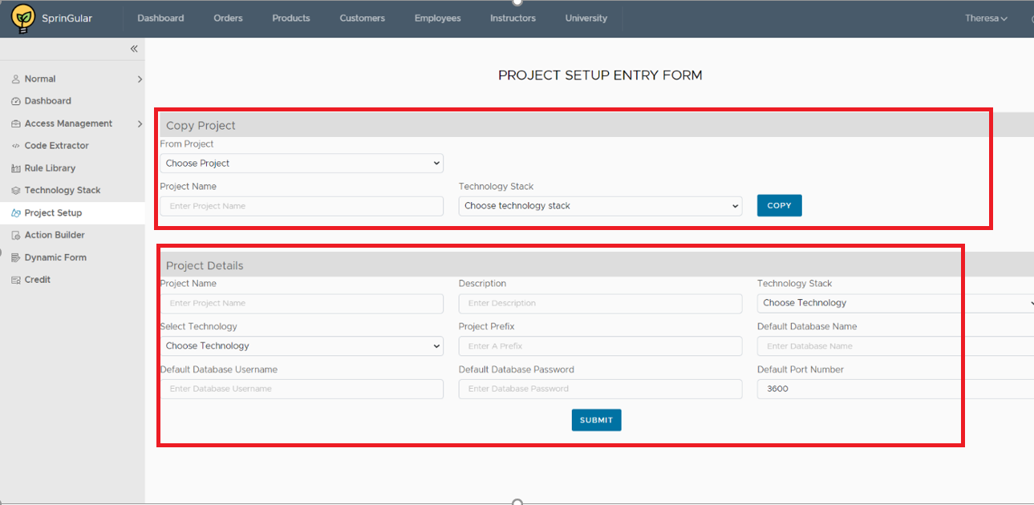

**Technical details: on click add button in project setup**

1. **Controller:** Rn_projectSetupController
2. **Service:** Rn_ProjectSetup_Service
3. **Entity:** Rn_Project_Setup
4. **Repository:** Rn_ProjectSetup_repository
5. **Table:** Rn_Project_Setup

**Populated fields :**

**Dropdown:** static

**Service** : projectsetupservice

**On click copy button:** when we click copy button it copies all data from existing technology which you are selected and build project setup.

**On click submit button:** when we click submit button it takes all entered data in the project details form and build project setup .

* In the project setup view menu click module button to setup the modules.

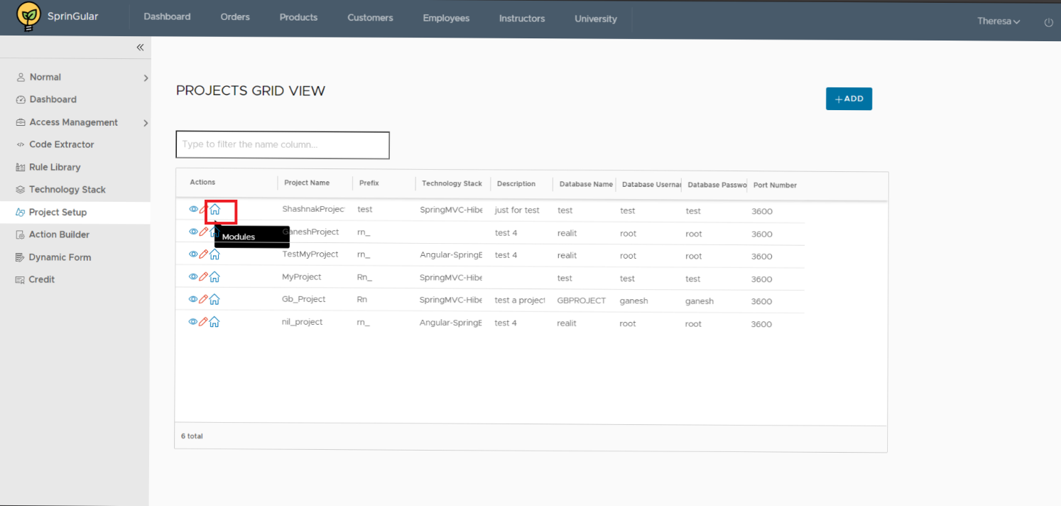

**Technical details: on click module button**

1. **Controller:** Rn_ModuleSetupController
2. **Service:** Rn_ModuleSetup_Service
3. **Entity:** Rn_Module _Setup
4. **Repository:** Rn_ModuleSetup_repository
5. **Table:** Rn_Module _Setup

* In the module setup grid-view click Add button to create module.

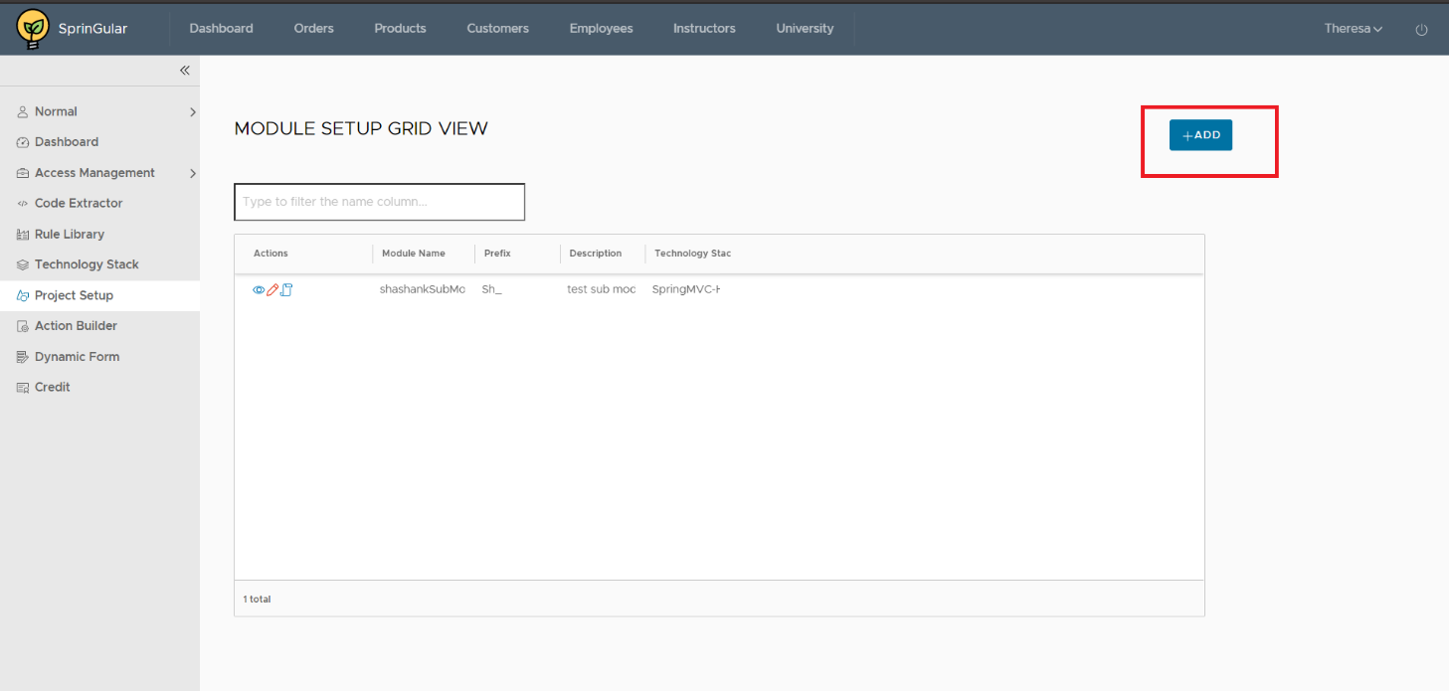

**Technical details: on click Add button in module setup grid view**

1. **Controller:** Rn_ModuleSetupController
2. **Service:** Rn_ModuleSetup_Service
3. **Entity:** Rn_Module _Setup
4. **Repository:** Rn_ModuleSetup_repository
5. **Table:** Rn_Module_Setup

**On click add button :**  It will got-to the module setup entry form.

* If you want to copy existing module then fill the copy module information like choose project ,choose module, module name and click copy to generate project.
* If you want to create new module fill the module details like module name ,description , module prefix then click submit to generate module.
* Then you’re redirect to the module setup grid-view .

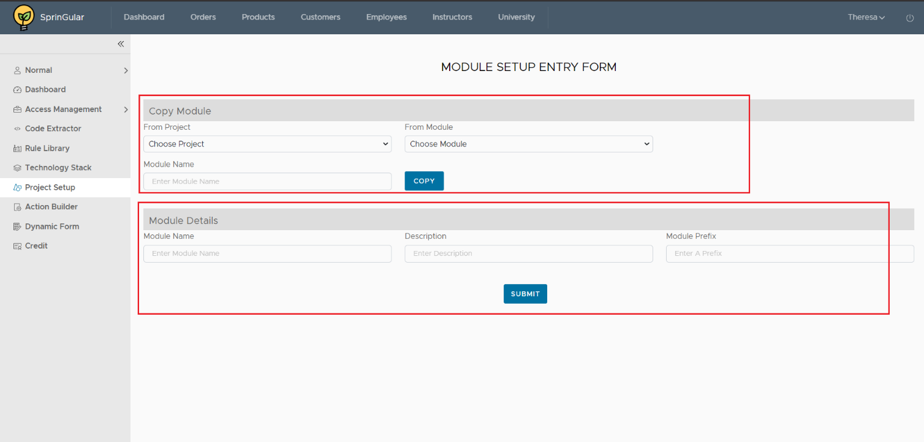

**Technical details: on click Add button in module**

1. **Controller:** Rn_ModuleSetupController
2. **Service:** Rn_ModuleSetup_Service
3. **Entity:** Rn_Module _Setup
4. **Repository:** Rn_ModuleSetup_repository
5. **Table:** Rn_Module_Setup

**Populated fields :**

**Service** : module_setupservice

**On click copy button:** when we click copy button it copies all data from existing module which you are selected and build module.

**On click submit button:** when we click submit button it takes all entered data in the module details form and build module .

* In the module grid-view setup click action button of your module to select actions like create table, form builder, report builder, api builder, bi builder, query builder, app builder, wireframe builder.
* Click wireframe builder then you’ll go-to wireframe grid-view.

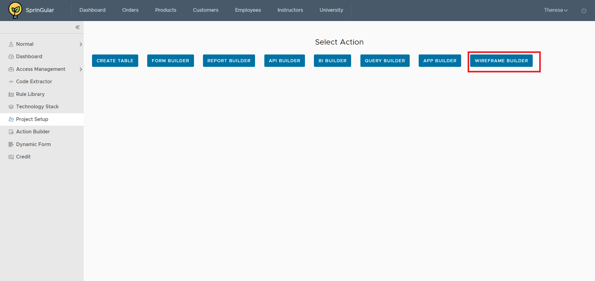

**Technical details: on click wireframe**

**Populated fields :** select actions

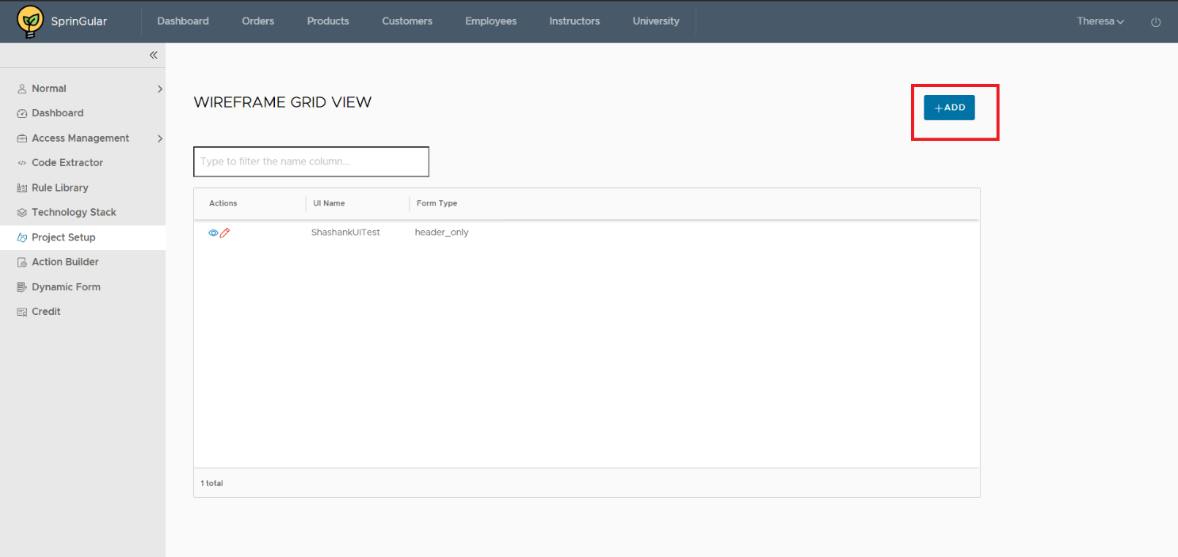

**Technical details: on click wireframe**

1. **Controller:** Rn_WireFrameController
2. **Service:** Rn_WireFrame_Service
3. **Entity:** Rn_Fb_Header
4. **Repository:** Rn_Fb_Header_repository
5. **Table:** Rn_Fb_Header

* In the wireframe grid-view click add button .
* Choose form type from the list (header line ,header-lines ,only lines ,multiple lines) and Then open define wireframe page.

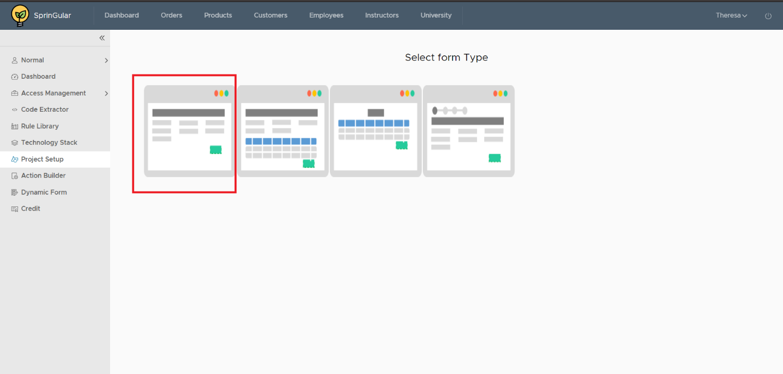

**Technical details: on click Add button in module**

**Populated fields :** Form types

* In the define wireframe If you want to copy existing wireframe then fill the copy wireframe form and click copy to generate project.
* If you want to create new wireframe fill the wireframe entry form then click submit to generate wireframe.

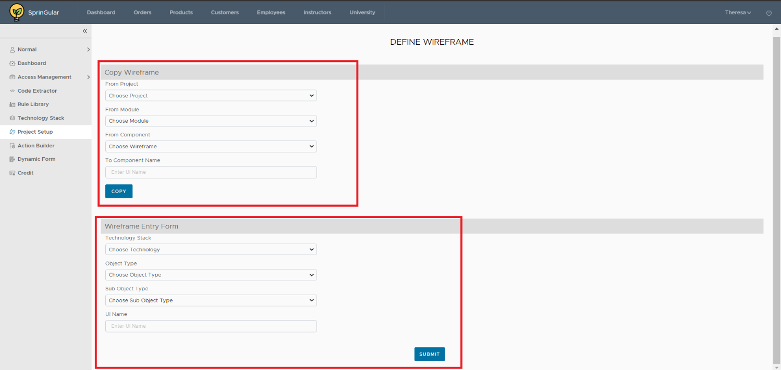

**Technical details: on click form type**

1. **Controller:** Rn_WireFrameController
2. **Service:** Rn_WireFrame_Service
3. **Entity:** Rn_Fb_Header
4. **Repository:** Rn_Fb_Header_repository
5. **Table:** Rn_Fb_Header , Rn_Fb_Line

**Populated fields :**

**Service** : wireframeservice

**On click copy button:** when we click copy button it copies all data from existing wireframe which you are selected and build wireframe.

**On click submit button:** when we click submit button it takes all entered data in the wireframe details form and build wireframe .

* After submitting wireframe you’ll redirect to the wireframe grid view form click edit button shown in image

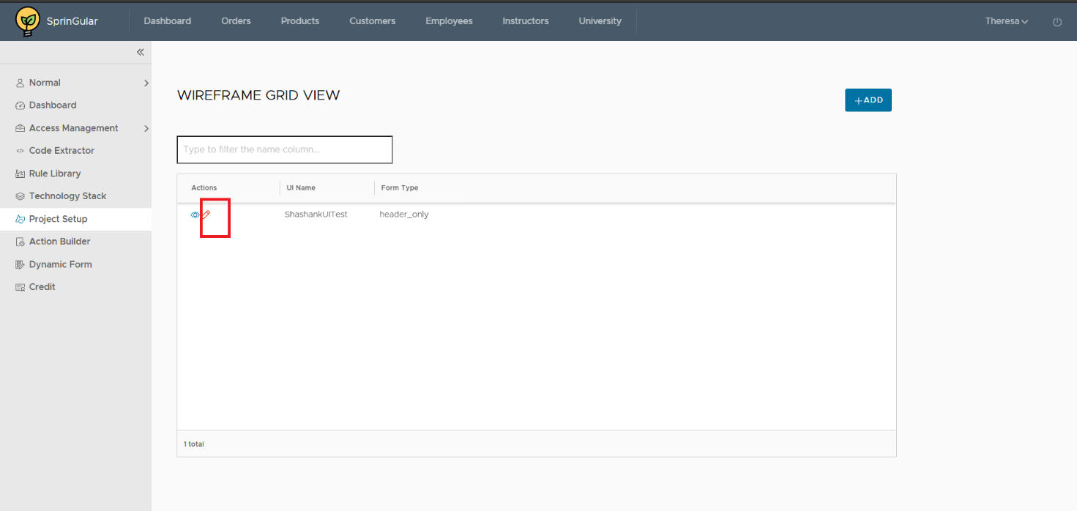

**Technical details: after on submit**

1. **Controller:** Rn_WireFrameController
2. **Service:** Rn_WireFrame_Service
3. **Entity:** Rn_Fb_Header
4. **Repository:** Rn_Fb_Header_repository

**Table:** Rn_Fb_Header , Rn_Fb_Line

* After clicking edit button you’ll go-to the ui section page where you add section and labels .
* After adding labels and sections you go for build button and click for build project.

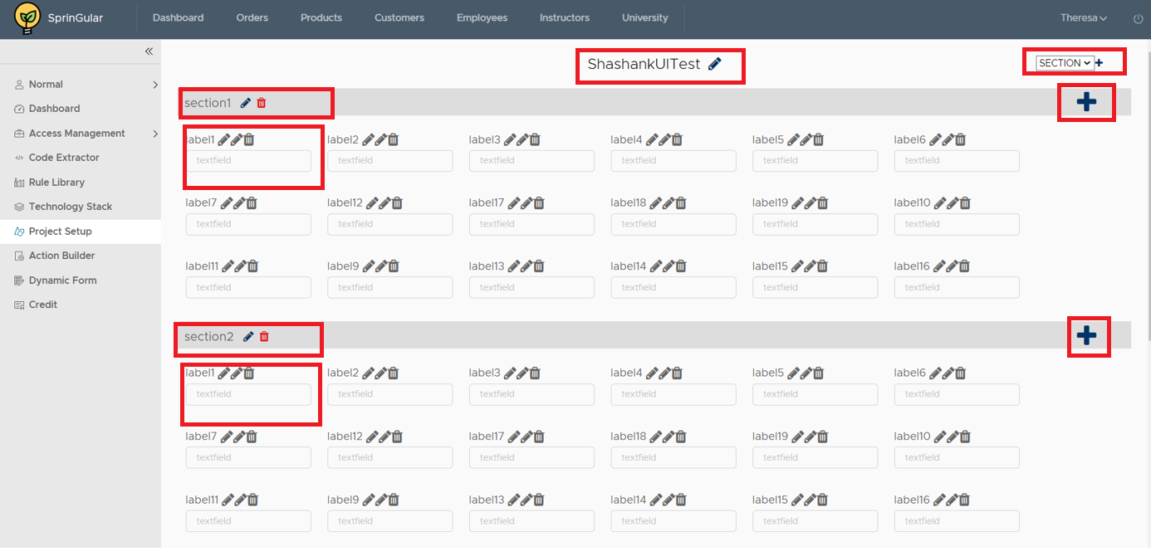

**Technical details: after on submit**

1. **Controller:** Rn_WireFrameController
2. **Service:** Rn_WireFrame_Service
3. **Entity:** Rn_Fb_Header
4. **Repository:** Rn_Fb_Header_repository
5. **Table:** Rn_Fb_Header , Rn_Fb_Line

**Populated fields:**

Add labels : dynamic

Add sections : dynamic